LAB 6

Laplace Transforms and MATLAB

Jordan Hayes

EGR323: Signals and Systems Analysis

6/24/2021

Prof. Krug

**Objective**

The objectives of the laboratory are to explore the Laplace transform in both the time and frequency domains. The Laplace transform of a system’s impulse response is expressed in Eq. (1)

$H\left(s\right)=\frac{Y\left(s\right)}{X(s)}$ (1)

Where *N(s)* and *D(s)* are the numerator and denominator polynomials. The roots of the numerator are the zeros of the impulse response ($H\left(s\right)= 0$); the roots of the denominator are the poles($H\left(s\right)= ∞$). The roots play an important role in the study of LTI systems and can be used to identify the region of convergence (ROC). Partial fraction expansion will also be practiced using MATLAB results. There are many forms of a transfer function expansion.

**Procedure and Results**

**Part I:**

It is convenient to display the impulse response graphically in pole-zero plot. The causal LTI system whose input, *x(t),* and output, *y(t),* satisfy the following differential equations.

$\frac{d^{3}y\left(t\right)}{dt^{3}}+4\frac{d^{2}y\left(t\right)}{dt^{2}}+14\frac{dy\left(t\right)}{dt}+20y\left(t\right)=2\frac{d^{2}x\left(t\right)}{dt^{2}}+5\frac{dx\left(t\right)}{dt}+12x(t)$ (2)

$\frac{d^{3}y\left(t\right)}{dt^{3}}+2\frac{d^{2}y\left(t\right)}{dt^{2}}+10\frac{dy\left(t\right)}{dt}=2\frac{d^{2}x\left(t\right)}{dt^{2}}+5\frac{dx\left(t\right)}{dt}+12x(t)$ (3)

$\frac{dy\left(t\right)}{dt}-3y\left(t\right)= \frac{d^{2}x\left(t\right)}{dt^{2}}+2\frac{dx\left(t\right)}{dt}+5x(t)$ (4)

The equations are transformed into the Laplace domain to find each system’s transfer function.

*Using the differential property on Eq. (2)*

$$=s^{3}*Y\left(s\right)+4s^{2}*Y\left(s\right)+14s*Y\left(s\right)+20*Y\left(s\right)=2s^{2}*X\left(s\right)+5s*X\left(s\right)+12*X(t)$$

*Factor out Y(s) and X(s)*

$$Y\left(s\right)\left[s^{3}+4s^{2}+14s+20\right]=X\left(s\right)\left[ 2s^{2}+5s+12\right]$$

*Using Eq. (1)*

$H_{1}\left(s\right)=\frac{Y\left(s\right)}{X(s)}=\frac{2s^{2}+5s+12}{{(s}^{3}+4s^{2}+14s+20)}$ (5)

*The process was repeated for Eq. (3) and (4)*

$H_{2}\left(s\right)= \frac{2s^{2}+5s+12}{s^{3}+2s^{2}+10s}$ (6)

$H_{3}\left(s\right)=\frac{s^{2}+2s+5}{s-3}$ (7)

The MATLAB *roots()* function was used to identify the zeros and poles of the transfer functions, shown below in MATLAB output window.

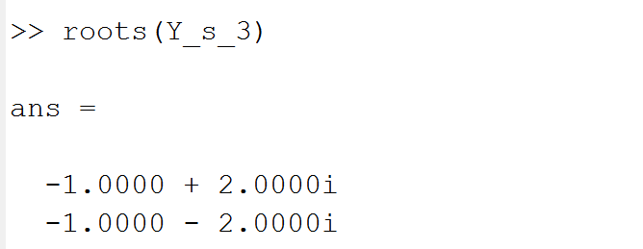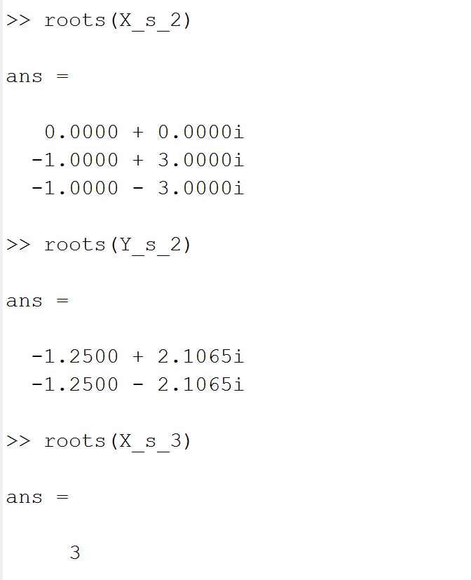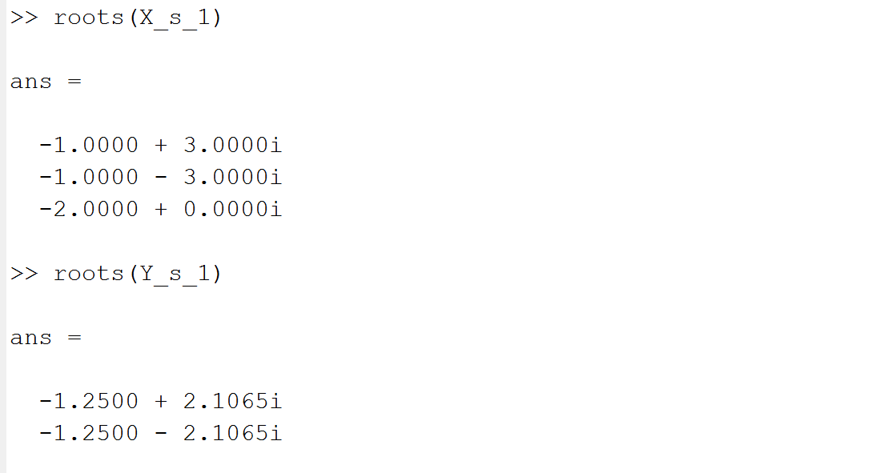

**Figure 1: MATLAB Output Window From *roots()* Function**

2D pole-zero plots are created for each of the systems.

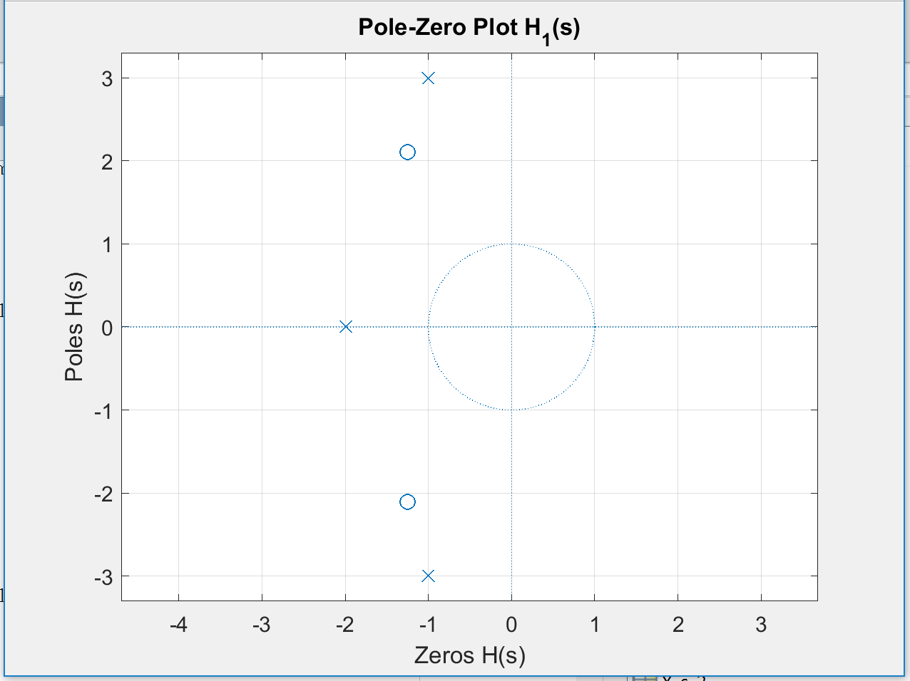

**Figure 2: Pole – Zero Plot for $H_{1}\left(s\right)$**

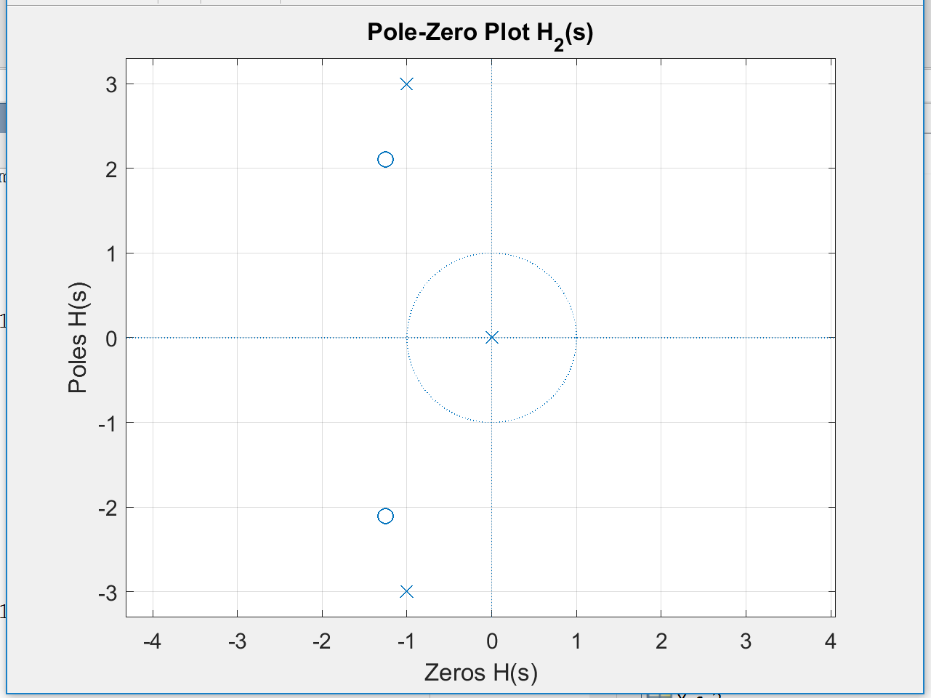

**Figure 3: Pole – Zero Plot for $H_{2}\left(s\right)$**

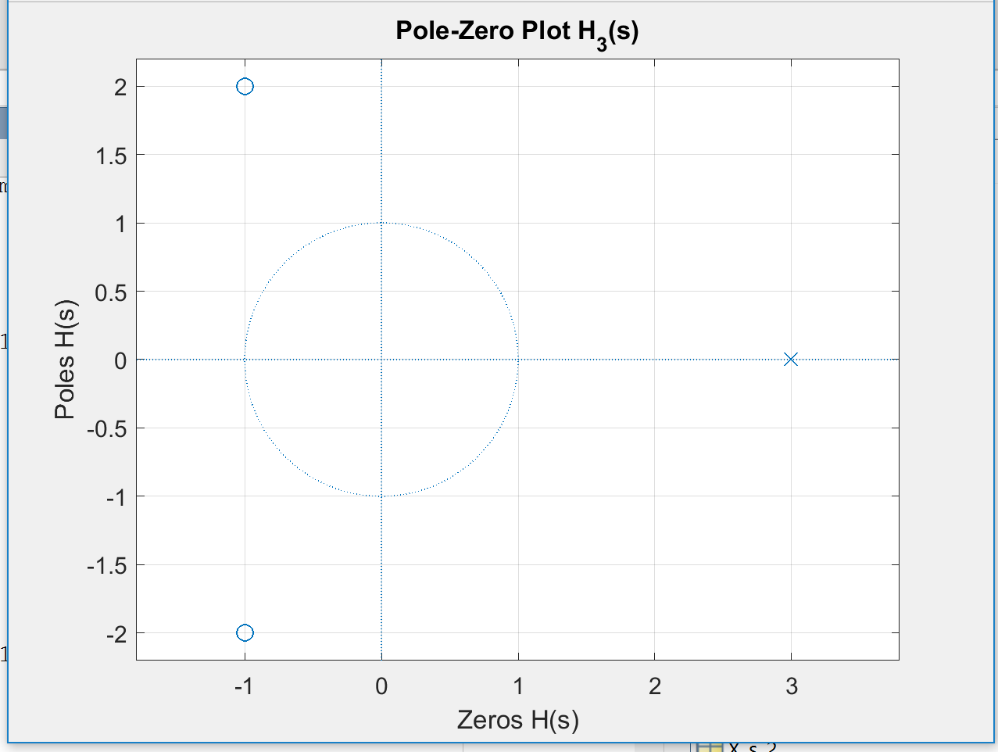

**Figure 4: Pole – Zero Plot for $H_{3}\left(s\right)$**

Another way to visualize the s-domain pole-zero plot is to view the magnitude of $H_{x}(s)$

across the s-plane by choosing a range of s values and plotting the response at those

values. Two vectors are defined to cover the desired range of the real-part (sigma) and imaginary-part (omega), making a 2D matrix space .3D magnitude plots of each transfer function are created for each of the systems using the *mesh()* function with inputs *sigma, omega,* and the absolute value of the transfer function’s magnitude.

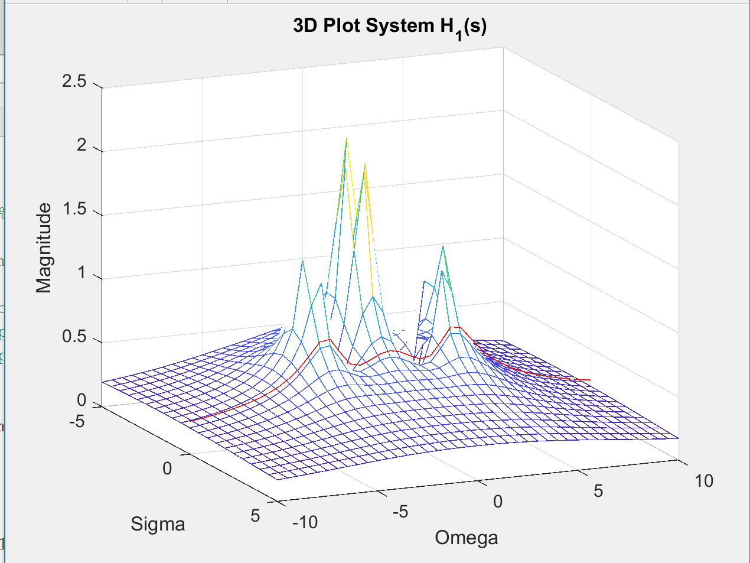

**Figure 5: 3D Magnitude Plot for $H_{1}\left(s\right)$**

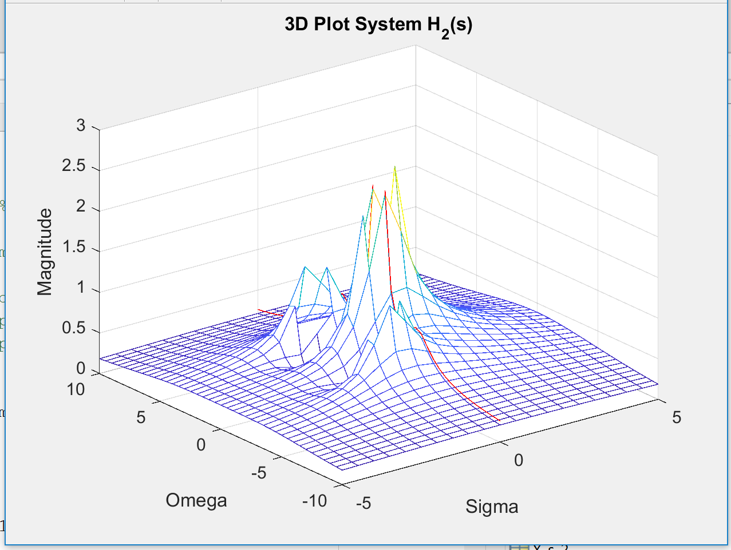

**Figure 6: 3D Magnitude Plot for $H_{2}\left(s\right)$**

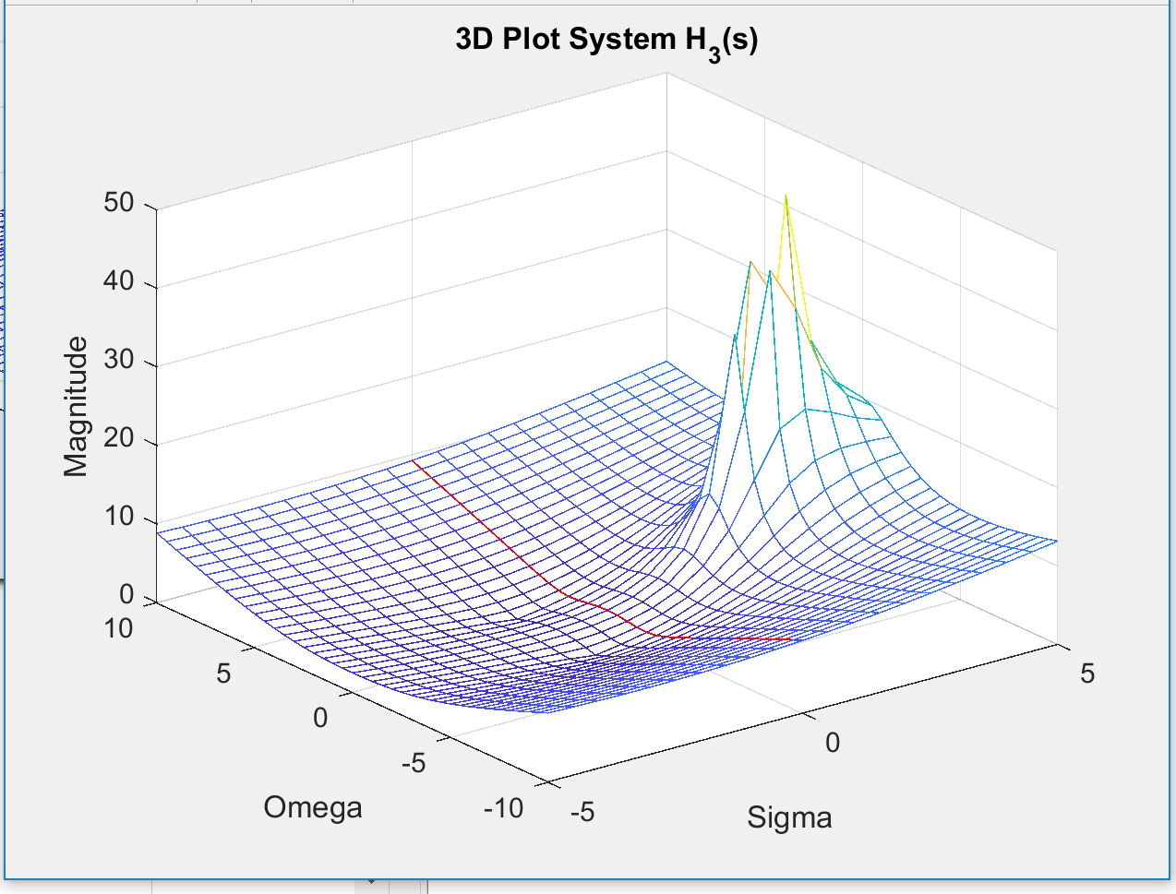

**Figure 7: 3D Magnitude Plot for $H_{3}\left(s\right)$**

The MATLAB *residue()* function was used to aid in finding the inverse Laplace Transform. The function performs the partial fraction expansion of the polynomial based transfer function. The output window in shown below.

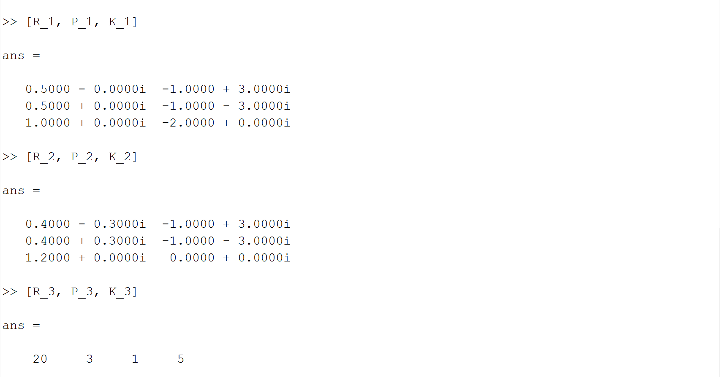

**Figure 8: MATLAB Output Window From *residue()* Function**

Using these values in the form of the final expansion, where the denominators are the poles, yields:

$$H_{1}\left(s\right)=\frac{.5}{s-(-1+3j)}+\frac{.5}{s-(-1-3j)}+\frac{1}{s+2}$$

$H_{2}\left(s\right)=\frac{.4-.3j}{s-(-1+3j)}+\frac{.4+.3j}{s-(-1-3j)}+\frac{1.2}{s}$

$H_{3}\left(s\right)=\frac{20}{s-3}+\left(s+5\right)$

Known Inverse Laplace transforms are used to transform the partial fraction expansions into the time domain.

$$h_{1}\left(t\right)=.5e^{-t}\left(\cos\left(3t\right)+jsin\left(3t\right)\right)+ .5e^{-t}\left(\cos\left(-3t\right)+jsin\left(-3t\right)\right)+e^{-2t}$$

$$h_{2}\left(t\right)=\left(.4-.3j\right)e^{-t}\left(\cos\left(3t\right)+jsin\left(3t\right)\right)+\left(.4+.3j\right)e^{-t}\left(\cos\left(-3t\right)+jsin\left(-3t\right)\right)+1.2$$

$$h_{3}\left(t\right)=20 e^{-3t}+\frac{d}{dt}δ\left(t\right)+5δ\left(t\right)$$

**Results and Discussion**

*4. Is there a problem with the system in Eq. (4)?*

There is a problem with the system in Eq. (4). The most descriptive form of H(s) is shown below.

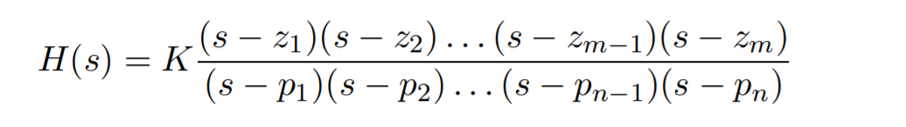

Where M must be less than N for the system to be causal. In order for a linear system to be stable, all of its poles must have negative real parts, that is they must all lie within the left-half of the s-plane. An “unstable” pole, lying in the right half of the s-plane, generates a component in the system homogeneous response that increases without bound from any finite initial conditions. This can also be seen by the Bode plot of $H_{3}\left(s\right),$ where the gain seems to increase linearly, and will do so without bound.

*5. Assuming causality, are all of the expansions valid? Are all of the time-domain response signals realizable?*

The time domain equations for $H_{1}\left(s\right)$ and $H_{2}\left(s\right)$ are valid because there are more poles than zeros; therefore, the magnitude of the frequency response tends to zero as the frequency approaches infinity. The time domain equation is also real valued if the magnitudes of the values inside terms are used. The imaginary parts of the equations are simply oscillating perpendicular to the real. We cannot assume causality for $H_{3}\left(s\right)$. If a system has more zeros, the gain increases without bound as the frequency increases. This cannot happen in physical energetic systems because it implies an infinite power gain through the system. A function is only causal if the transfer function is absolutely integrable.